**Chicago Harley-Davidson Project**

**DSC 451 Database Design for IS**

Yue You

**Introduction**

The database system is a structural data collection that organizations used to meet their business needs. Data is entered into the system and accessed on a routine basis by assigned users. It handles various types and large capacity of data efficiently. The design of the database can be critical to serving multiple use-purposes.

As a data analyst, it is necessary to understand the relational database design and be able to extract the target data from the database system. On the other hand, be able to understand the relational database will make the preliminary data cleaning and analysis much easier.

The study of this project to investigate the database relation based on three business transaction invoices from Chicago Harley-Davidson. Through understanding the data in and out on the invoices, three destinated goals need to be achieved in this study:

1. To create an Entity Relation Diagram, which represents the data relations on the invoices.
2. To develop the DDL and populate the data into the relational schema.
3. To develop SQL queries to execute demands.

**Project Source: Harley-Davidson Transaction Invoices**

The invoices below represent the three pieces of transactions that took place in Oct. 2003, Nov. 2006 and Dec. 2006.

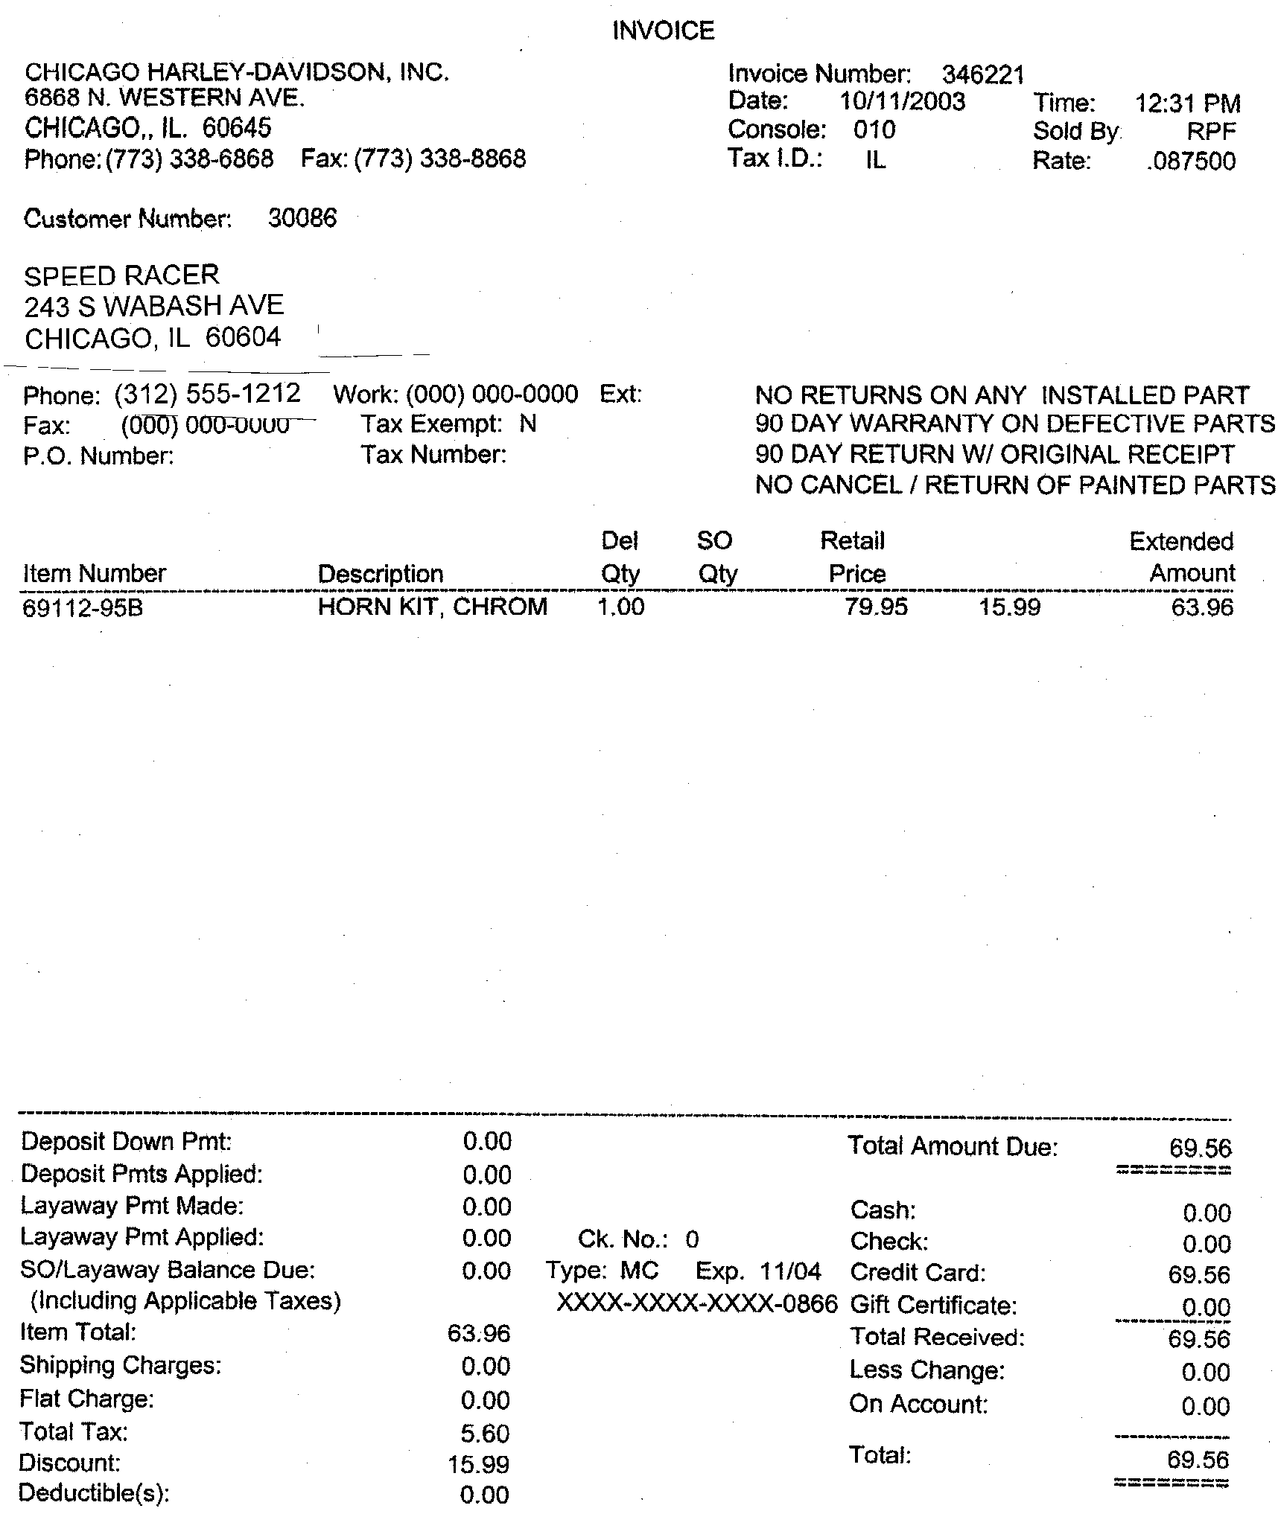

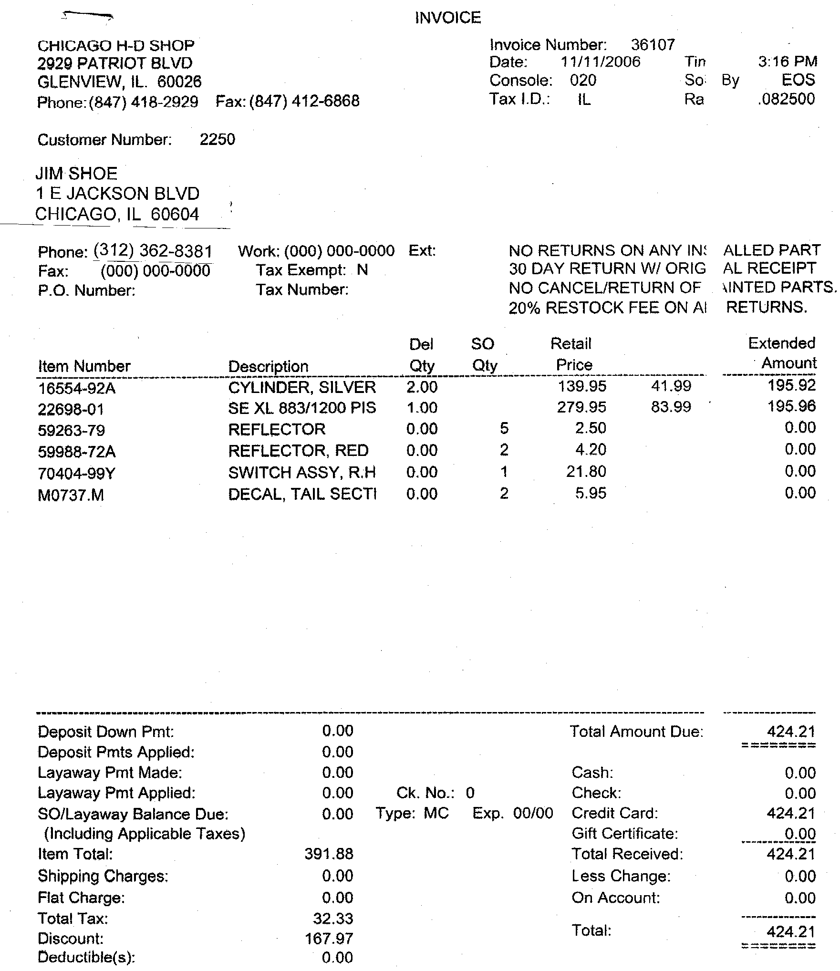

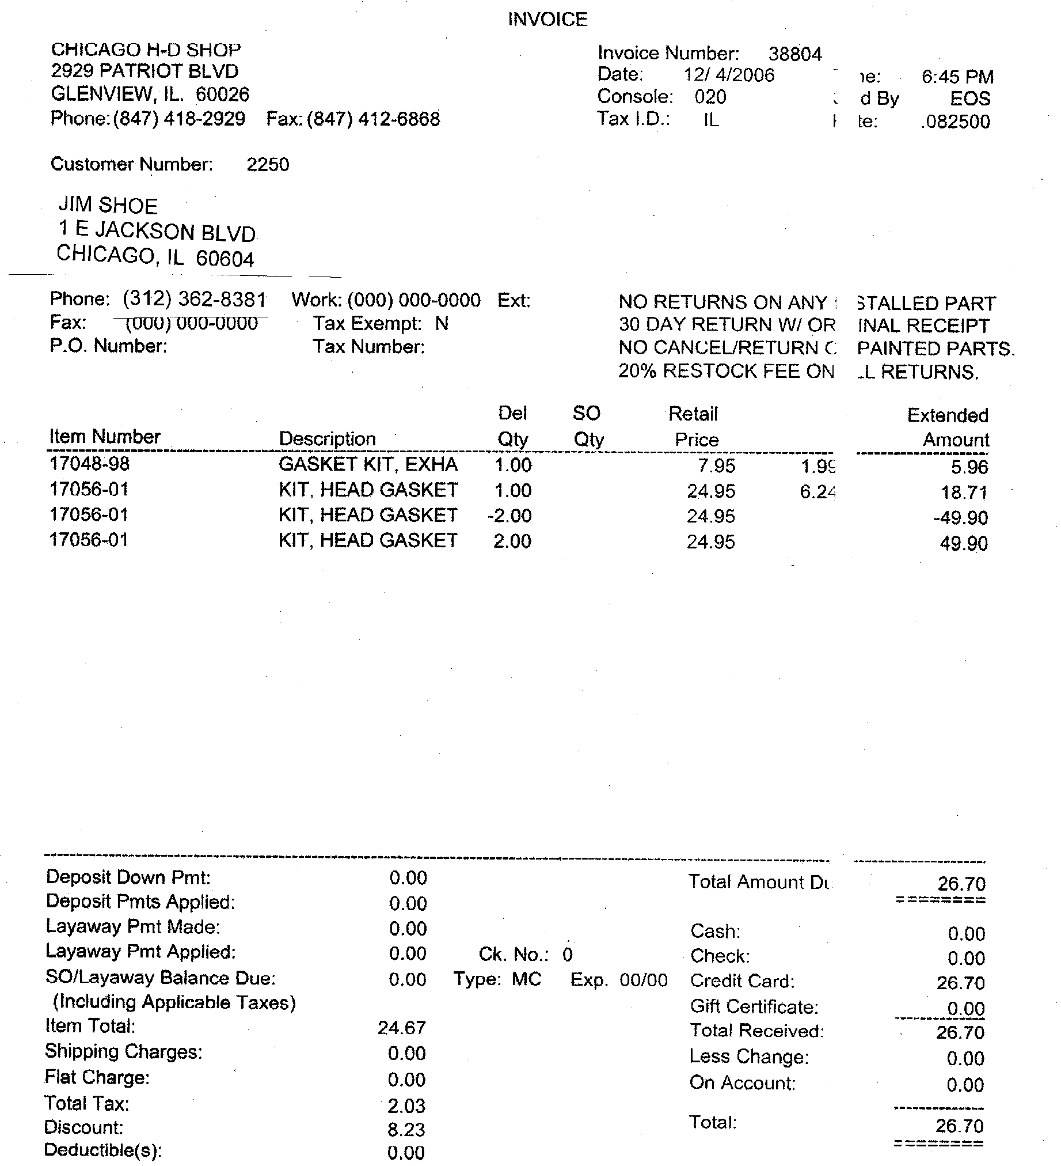

Each page of the invoices includes various information, such as time, shop, item, item quality, customer info, and the transaction info. To connect the data, we first need to build logical entity-relationship among the all given data. The first step can be done by splitting the attributes and data from large data entry present on the invoices. This step is to help to clarify the information and to know how they possibly linked to each other. The second step is normalization. Normalization is needed to remove the partial dependencies and transitive dependencies so that there won’t be inconsistent data or anomalies when we update the data in the database. After that, the entity-relationship diagram can be created based on a 3rd normal form relations.

**Normalization**

**1st Normal Form**

Based on the given information on the invoices, it initially got break down into the five entities. The tables below show the relevant attributes and transaction activities. However, tables are still in the original 1NF (first normal form), which can be found by the data redundancy show in these tables. In order to build entity-relationship and remove the redundancy from the database, we need to transform the first normal form into the second normal form.

***Invoice***

***Shop***



***Customer***



***Item (Product)***

***Transaction***

**2nd Normal Form**

The normalization of 1NF relations to 2NF involves the removal of partial dependencies. If a partial dependency exists, we remove the partially dependent attributes from the relation by placing them in a new relation along with a copy of their determinant. This step of normalization is aimed to connect the 1-to-1 relations and the 1-to many relations as well.

To creating both entity relations, we need to define the primary keys of each entity table and to identify the high and low cardinalities of each table. High cardinality contains unique or uncommon data. On the other hand, low cardinality has more common or repeated data. The relations between tables are based on the high and low cardinality; they connect the entities' tables by clearly identifying the primary keys and foreign keys. The tables below are just examples of the 2nd normal form. The very first column of each table is the primary key of each entity table. There is an entity-relationship diagram created by Oracle SQL Developer with DDL that shows the relationship among entities. Since the invoices did not indicate any many-to-many relations, it won't be required to conduct further normalization to the 3rd normal form. However, the 3rd normal form can be done for this specific case.

***Shop***



***Customer***



***Item (Product)***

***Invoice***



**ER-Diagram**

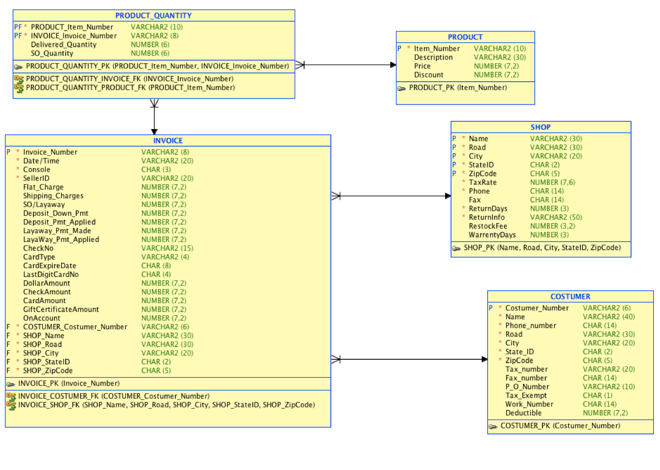

1. DDL code:

CREATE TABLE product (

item_number VARCHAR2(10) NOT NULL,

description VARCHAR2(30),

price NUMBER(7,2),

discount NUMBER(7,2)

);

ALTER TABLE product ADD CONSTRAINT product_pk PRIMARY KEY ( item_number );

CREATE TABLE shop (

name VARCHAR2(30) NOT NULL,

road VARCHAR2(30) NOT NULL,

city VARCHAR2(20) NOT NULL,

stateid CHAR(2) NOT NULL,

zipcode CHAR(5) NOT NULL,

taxrate NUMBER(7,6) NOT NULL,

phone CHAR(14) NOT NULL,

fax CHAR(14),

returndays NUMBER(3) NOT NULL,

returninfo VARCHAR2(50) NOT NULL,

restockfee NUMBER(3,2),

warrentydays NUMBER(3)

);

ALTER TABLE shop

ADD CONSTRAINT shop_pk PRIMARY KEY ( name,

road,

city,

stateid,

zipcode );

CREATE TABLE costumer (

costumer_number VARCHAR2(6) NOT NULL,

name VARCHAR2(40) NOT NULL,

phone_number CHAR(14) NOT NULL,

road VARCHAR2(30) NOT NULL,

city VARCHAR2(20) NOT NULL,

state_id CHAR(2) NOT NULL,

zipcode CHAR(5) NOT NULL,

tax_number VARCHAR2(20),

fax_number CHAR(14),

p_o_number VARCHAR2(10),

tax_exempt CHAR(1),

work_number CHAR(14),

deductible NUMBER(7,2)

);

CREATE TABLE invoice (

invoice_number VARCHAR2(8) NOT NULL,

"Date/Time" VARCHAR2(20) NOT NULL,

console CHAR(3) NOT NULL,

sellerid VARCHAR2(20) NOT NULL,

flat_charge NUMBER(7,2),

shipping_charges NUMBER(7,2),

"SO/Layaway" NUMBER(7,2),

deposit_down_pmt NUMBER(7,2),

deposit_pmt_applied NUMBER(7,2),

layaway_pmt_made NUMBER(7,2),

layaway_pmt_applied NUMBER(7,2),

checkno VARCHAR2(15),

cardtype VARCHAR2(4),

cardexpiredate CHAR(8),

lastdigitcardno CHAR(4),

dollaramount NUMBER(7,2),

checkamount NUMBER(7,2),

cardamount NUMBER(7,2),

giftcertificateamount NUMBER(7,2),

onaccount NUMBER(7,2),

costumer_costumer_number VARCHAR2(6) NOT NULL,

shop_name VARCHAR2(30) NOT NULL,

shop_road VARCHAR2(30) NOT NULL,

shop_city VARCHAR2(20) NOT NULL,

shop_stateid CHAR(2) NOT NULL,

shop_zipcode CHAR(5) NOT NULL

);

ALTER TABLE invoice ADD CONSTRAINT invoice_pk PRIMARY KEY ( invoice_number );

ALTER TABLE invoice

ADD CONSTRAINT invoice_costumer_fk FOREIGN KEY ( costumer_costumer_number )

REFERENCES costumer ( costumer_number );

ALTER TABLE invoice

ADD CONSTRAINT invoice_shop_fk FOREIGN KEY ( shop_name,

shop_road,

shop_city,

shop_stateid,

shop_zipcode )

REFERENCES shop ( name,

road,

city,

stateid,

zipcode );

CREATE TABLE product_quantity (

product_item_number VARCHAR2(10) NOT NULL,

invoice_invoice_number VARCHAR2(8) NOT NULL,

delivered_quantity NUMBER(6),

so_quantity NUMBER(6)

);

ALTER TABLE product_quantity ADD CONSTRAINT product_quantity_pk PRIMARY KEY ( product_item_number,

invoice_invoice_number );

ALTER TABLE product_quantity

ADD CONSTRAINT product_quantity_invoice_fk FOREIGN KEY ( invoice_invoice_number )

REFERENCES invoice ( invoice_number );

ALTER TABLE product_quantity

ADD CONSTRAINT product_quantity_product_fk FOREIGN KEY ( product_item_number )

REFERENCES product ( item_number );

**Testing**

The final step of this project is to test the validity of the logical database. There are two testings involved in the step. By executing the DDL code, we need to answer two questions:

1. How many parts did Jim Shoe purchase in November, 2006?

SELECT SUM (delivered_quantity) +

SUM (SO_quantity) as purchased_quantity

FROM product_quatity

WHERE invoice_invoice_number IN (

SELECT invoice_number

FROM invoice

WHERE SUBSTR (“Date/Time, 4,8) = ‘NOV-2006’

AND customer_customer_number IN (

SELECT customer_number

FROM customer

WHERE name = ‘Jim Shoe’))

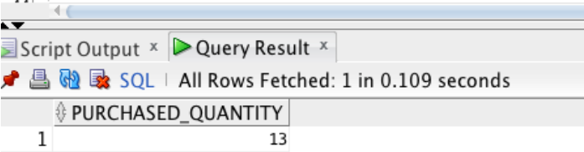

1. What was the total amount of all purchase by Speed Racer?

CREATE VIEW tax AS

SELECT SUM ((price – discount) * (taxrate)) AS tax

FROM Product, Product_quantity, Invoice, Shop

WHERE PRODUCT.ITEM_NUMBER = PRODUCT_QUANTITY.PRODUCT_ITEM_NUMBER

AND PRODUCT_QUANTITY.INVOICE_INVOICE_NUMBER = invoice.invoice_number

AND invoice.shop_name = shop.name

AND invoice_invoice_number IN (

SELECT invoice_number

FROM invoice

WHERE customer_customer_number IN (

SELECT customer_number

FROM customer

WHERE name = ‘Speed Racer’));

SELECT SUM ((price – discount) + (tax)) AS purchased_amount

FROM product, tax, Product_quantity, Invoice, Shop

WHERE PRODUCT.ITEM_NUMBER = PRODUCT_QUANTITY.PRODUCT_ITEM_NUMBER

AND PRODUCT_QUANTITY.INVOICE_INVOICE_NUMBER = invoice.invoice_number

AND invoice.shop_name = shop.name

AND invoice_invoice_number IN (

SELECT invoice_number

FROM invoice

WHERE customer_customer_number IN (

SELECT customer_number

FROM customer

WHERE name = ‘Speed Racer’));

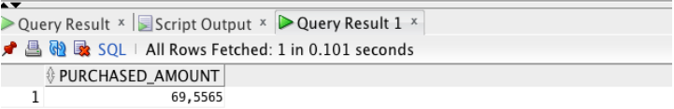

Based on these two testing, we can certainly verify the validity of the DDL and the logical relationship among the entities from the invoice data.

**Conclusion**

The purpose of this project is to learn and apply the database entity-relationship through a practical case study. This case study is creatively designed with three pieces of the invoice, which is very useful and helpful to understand how databases were designed to improve the efficiency of business activities and integrity and quality of data storage. As a data analyst, the design of the database helped us to understand the data correlations. On the other hand, a good design of the database will reduce the amount of preliminary data cleaning process.